**Task: Setting up Jenkins for Continuous Integration/Continuous Deployment (CI/CD)**

Description:

Configure Jenkins to automate the build, test, and deployment processes for your application.

Jenkins Installation and Configuration:

Test Case 1: Verify that Jenkins is successfully installed on the designated server.

Expected Outcome: Jenkins should be installed without errors, and the web interface should be

accessible.

2. CI Pipeline Execution:

Test Case 2: Trigger a sample commit in the version control system and ensure that the CI

pipeline is automatically executed.

Expected Outcome: The CI pipeline should fetch the latest code, compile it, run automated

tests, and produce deployable artifacts.

3. CD Pipeline and Deployment:

Test Case 3: Manually trigger the CD pipeline and confirm that the application is deployed to a

staging environment.

Expected Outcome: The CD pipeline should deploy the application successfully, and the staging

environment should reflect the latest changes.

**Test Case 1: Verify that Jenkins is successfully installed on the designated server.**

**Expected Outcome: Jenkins should be installed without errors, and the web interface should be accessible.**

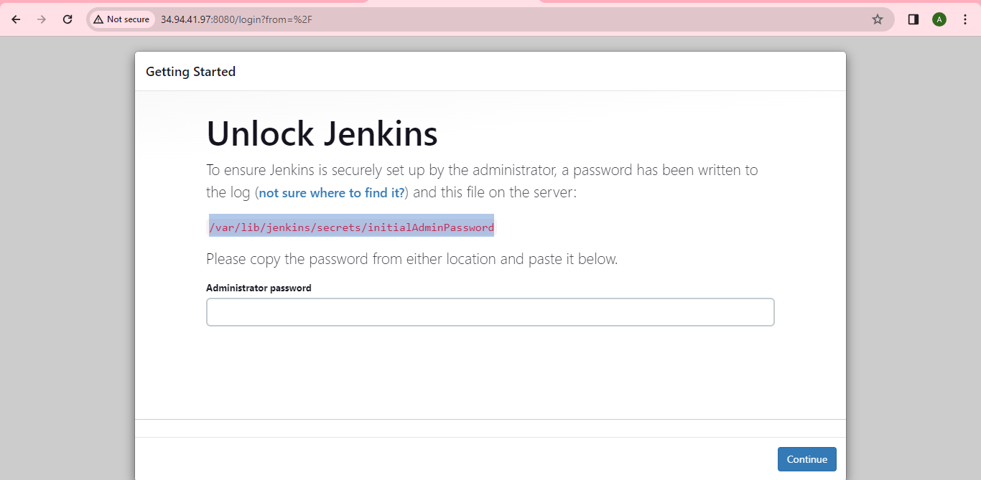

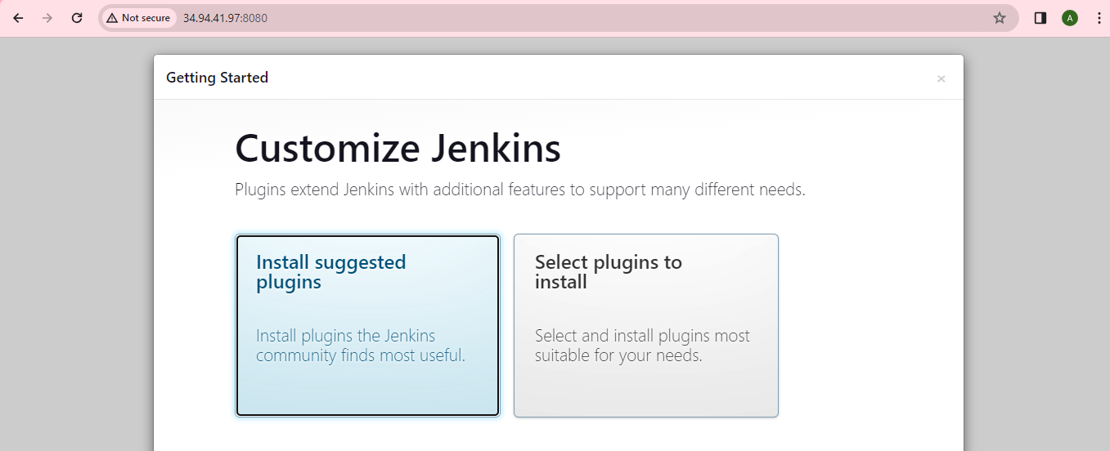

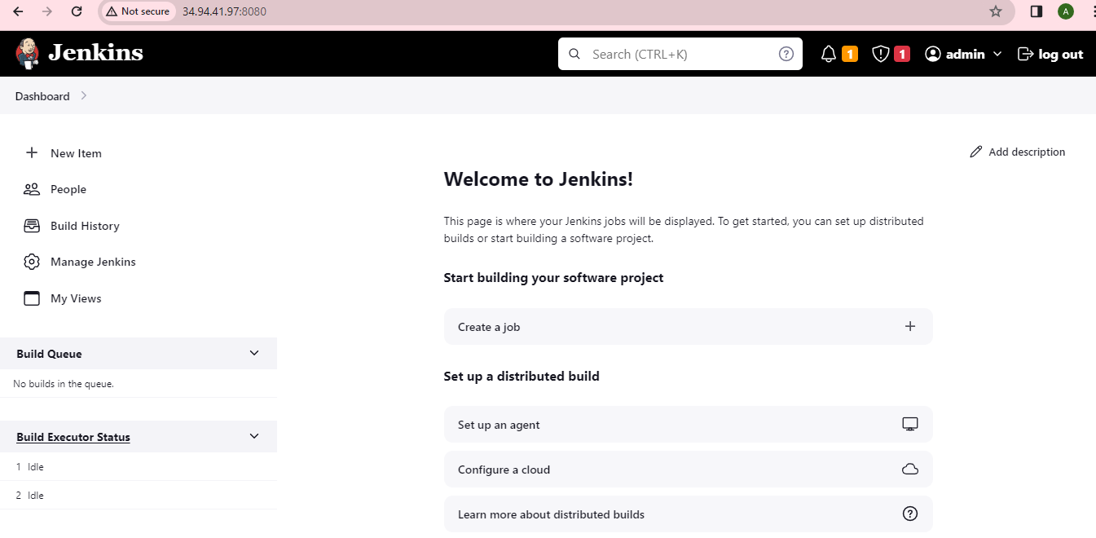

**2. CI Pipeline Execution:**

**Test Case 2: Trigger a sample commit in the version control system and ensure that the CI**

**pipeline is automatically executed.**

Expected Outcome: The CI pipeline should fetch the latest code, compile it, run automated

tests, and produce deployable artifacts.

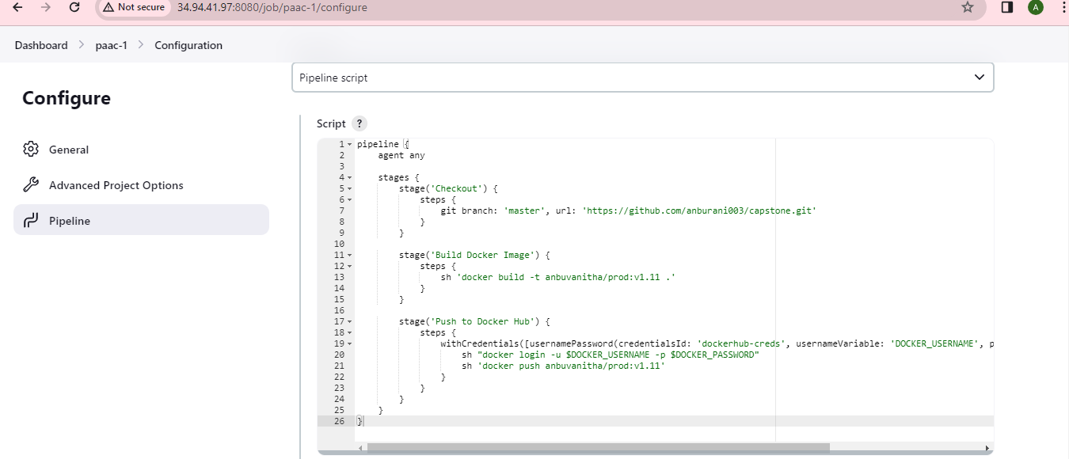

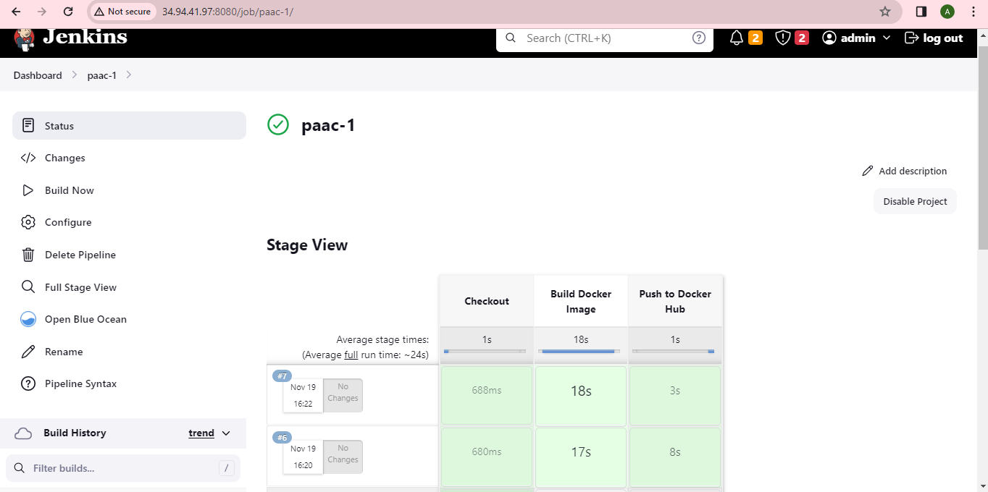

**3. CD Pipeline and Deployment:**

Test Case 3: Manually trigger the CD pipeline and confirm that the application is deployed to a

staging environment.

Expected Outcome: The CD pipeline should deploy the application successfully, and the staging

environment should reflect the latest changes

